305171 Computer Programming (First Semester, 2011)
Lab and Assignment 1: Prepare for the course
Due date June 15, 2011
Student 1: Name____________________________________________ ID _______________
Student 2: Name____________________________________________ ID _______________
Student 3: Name____________________________________________ ID _______________

Lab 1.1: Prepare your mind for programming.
Instruction
1. Go to website Light-Bot game http://armorgames.com/play/2205/light-bot and play the game. Try to play all levels (1-12) by yourself. This is a good game for students who do not have any experience in programming.
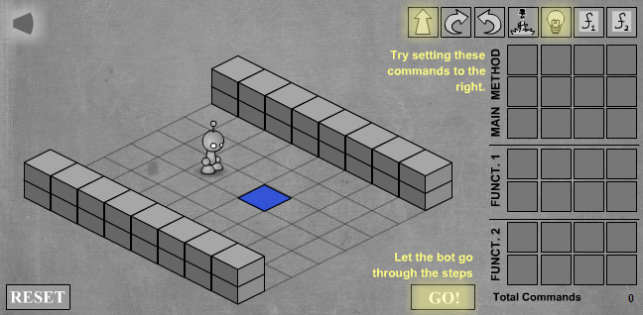
2. Do the assignment 1.1 – 1.2
Assignment 1.1: Write down the solutions for level 10, 11, and 12. Use the following notations:
M for moving forward L for turning on the light switch J for jumping
CW for turning clockwise CCW for turning counter-clockwise
F1 and F2 for function1 and function2, respectively.
Level | Main Method | Function 1 | Function2
2 | CW, M, CCW, M, M, M, M, CCW, M, L
10
11
12

Assignment 1.2: Choose one level from level 10, 11, or 12 and draw flowchart and its corresponding pseudo-code of the Light-Bot from that level.

Lab 1.2: Prepare your computer for C programming.
Instruction
1. Install Microsoft Visual C++ 2010 Express Edition on your computer (I assume that at least one student in a group has her own computer, if not, do it in the lab). The instruction on how to install and use the MS VC++ Express is in slide “03 - Install VC++ Express” on the course website.
2. Test with this code
/*
* HelloWorld.c - My first C program
*/

#include <stdio.h>
#include <conio.h>

int main()
{
printf("Hello world. \n");
printf("This is my first C program.\n");

getch();

return (0);
}

3. Run the program and capture the result screen and paste below.

Instruction on how to submit the assignments

1. Zip all files (lab sheet and all .c code) into one .zip (or .rar) file.
2. Rename the zip file to this format
XX_AAAAAAAA_BBBBBBBB_CCCCCCCC.ZIP
Where
XX = Assignment number with leading zero
AAAAAAAA = ID of student 1
BBBBBBBB = ID of student 2
CCCCCCCC = ID of student 3 (if any)
For example, the assignment 1 file might look like this.
01_53112345_53111111.ZIP
3. Attach the zip file and send e-mail to waranusast@gmail.com. The subject of email is the name of assignment, such as “assignment 1”, “assignment 5”. In the body part of the email, students must put the names and ids of the members of the group.

