Problems and Programmers Instructions

Introduction
Problems and Programmers is an educational software engineering card game. It is directed at students with a basic to intermediate background in software engineering. The game would optimally be used with students midway through an introductory course and who have been exposed to the discipline’s basic concepts. However, some problem cards expose players to ideas that would also be appropriate in a more advanced setting. In addition, a future version of this document will include a separate description of the rules, designed teach players entirely new to the discipline enough of the basics to play and learn from the game.

The game strives to teach players by simulating the software development process, from documentation to delivery, and on to delivery. Generally players following proper software engineering practices will be rewarded, while those taking risks and cutting corners will be punished. This punishment comes largely in the form of problem cards played by opposing players. The workings of the code system also is modeled after the real effects of software engineering and will reward wise players. By the end of several games, players will learn which courses of action are effective and which are dangerous. These lessons will be effective in the game, as well as in reality.

Your Goal
The goal of Problems and Programmers is simple, to be the first to finish the project. Each participant plays as a project manager, competing against the other to complete the project satisfactorily first. Each player works for the same company, but there is nothing wrong with a little internal competition. Over the course of the game, each of you will take a software engineering project from conception to completion, while trying to avoid the possible pitfalls of programming through planning, preparation and luck.

Setup
At the start of the game, shuffle each of the decks.
- The code deck has colored backs, and is the second largest deck.
- The main deck is the largest deck, and its cards instead have blank backs.
Place both of these decks between the players. Later in the game, when the time comes to discard any cards belonging to these decks, place them face-up next to them to form discard piles (if either of the decks run out you can shuffle the discard piles and re-use them).

The project deck has only 9 cards and is the smallest deck. The documentation deck meanwhile is slightly larger. Place these to the side, they will only be used at the beginning of the game and do not require discard piles.

Beginning of the Game
The first thing that happens at the start of the game is that a project is chosen at random from the projects pile. This represents the program that both players will be racing to complete. Place this project card in the middle of the play area between the players. The card information is repeated and flipped on the card so that both players have easy access to the projects properties. These are very important to the game and include:

- Complexity: This is how many time points a programmer needs to spend to complete one piece of good code. The two possibilities for this value are 2 or 4.
- Length: This is how many code cards must be completed to integrate and finish this project.
- Quality: This represents how bug-free the client expects the final product to be. In game terms, this is how many code cards will be drawn from your final project during the product delivery stage. All of these codes must be bug-free or the project will have to be partially redone.
- Budget: This is how much money you will have to spend on the project and will be a restriction on the programmers you are able to hire.

Don’t worry if some of these descriptions don’t make sense yet, they will be explained in more detail shortly.

The Main Deck

After every player has their project, each player draws five cards from the main deck (the large deck with the cards with blank backs).

Take a quick look at the cards in your hand. The Main Deck contains three types of cards: programmers, problems and concepts. Each has several important features, which are described in detail below:

Programmers
Programmers are at the heart of your implementation phase and are necessary for coding and generally getting the job done. They have 3 attributes players should look at before deciding whether or not to hire them:
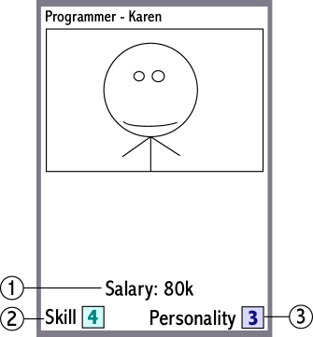 | 1) Salary: This is how much the programmer must be paid. Programmers with higher salaries will take up more of your budget.  2) Skill: This is the number of time points that a programmer gets per turn. Every action that a programmer takes requires a certain number of time points, and so a programmer with more speed can get more done in a turn. Skill is rated on a 1-5 scale, with 5 of course being the best.  3) Personality: This is the programmer’s tendency to be a good worker, rated on a 1-5 scale. This includes their friendliness, professionalness and how well they follow normal software engineering practices. The lower a programmer’s personality, the more vulnerable to problem cards they are.

When you play a programmer, place it to the right of any programmers you already have at the bottom of your play area.

Before you can play any programmer you must make sure that doing so would not cause the total of your programmers’ salaries and perks’ costs to exceed the budget for your project.

Problems
Problem cards represent things that go wrong during a software engineering project. They are played on an opponent during their implementation stages, but only if they meet certain criteria. Players taking proper precautions may be immune to some problems. Problem cards have 3 main parts to be considered:
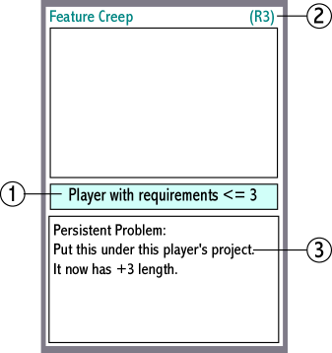 | 1) Criteria: This is what conditions must be met for you to be able to play this card on a given opponent. This is the card’s way of saying, “This card can only be played on a [criteria]”.  2) Criteria Abbreviation: This acts as a quick reference for the card’s criteria.  3) Effect: This is the effect on the player or programmer that this problem is played on. Most problems are used and then immediately placed in the discard pile. Persistent problems are placed in play and continue to hassle their recipients.

Also notice that problems are color-coordinated, from green to blue to red, in order of increasing severity.

You may play one problem card on your opponents during their implementation phase. But you may only do this if they or their programmers meet the criteria on the card. When you play a problem, if the recipient meets the crieria, they are subject to the effects of the problem. Some of the important terminology to note is:

- Discard [something]: When a card is discarded, place it in the appropriate discard pile. Documentation cards should merely be placed on the bottom of the decks they came from. The player playing the programmer always chooses the cards chosen, unless otherwise specified.
- Programmer is fired or quits: This programmer is discarded. Any code they have worked on is left.

Persistent problems should be placed as described in the problem. Project problems are placed on the side of the project card that is face-up for that player and represent effects that only they must deal with. Programmer problems should be placed in the area under the programmer they are effecting. If space is tight, the problems can actually be placed underneath their victims, as long as the name remains exposed.

Concepts
These represent optional decisions that may be made during a software lifecycle. All remain in play until discarded (placed in the discard pile) and may change how or how fast you progress. They have 2 important parts:

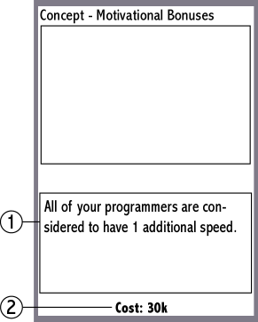 | 1) Effect: This is what this concept card does.  2) Cost: Some concepts have a cost. This is treated in the same manner as a programmer’s salary and cannot be played if it would cause a budget excess.

Concepts can be placed in any available space; the left side of the play area can be convenient. Those concepts with persistent effect effecting projects should be placed near them to indicate this.

Game Structure
Once all players have familiarized themselves with the cards in their hands, they can get started. The youngest player goes first. After each player’s turn, the next player in clockwise order takes a turn.

The Waterfall Model
In Problems and Programmers, players follow the well-known waterfall model for developing their project. The game uses a five-step version of the waterfall model, dividing implementation into two steps. Each step of the waterfall is then represented by a represented by a stage of the game.

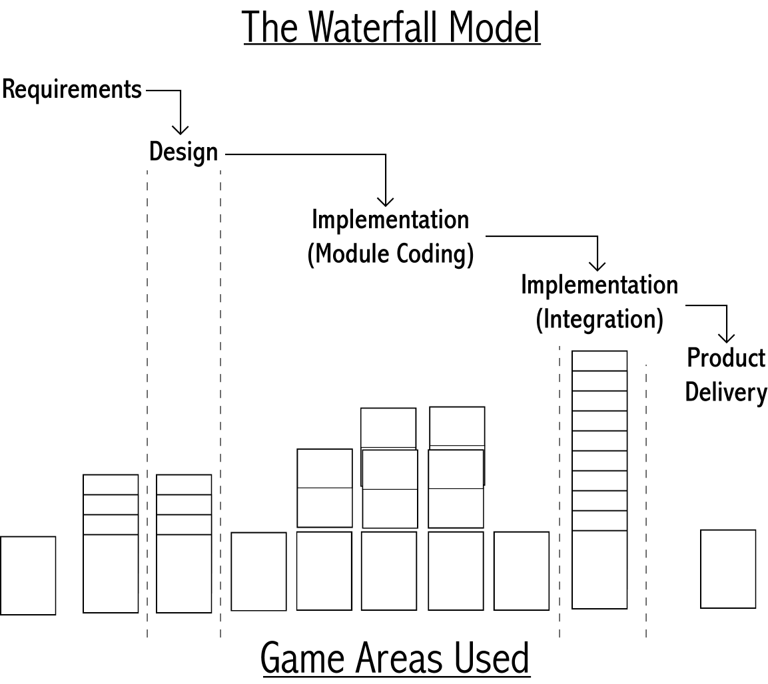

Each stage determines the actions that a player can take. Players may move on to the next stage in the lifecycle at their own pace, but once a player has moved on, there is no going back. The decisions made in each stage greatly effect the player later in the game; thus the decision to move on must not be taken lightly.

In general, each turn a player will take the following actions in this order:
- choose whether to move on to the next stage
- draw cards
- take action based on their stage
- play programmer and concept cards
- discard cards they don’t need

It is worth noting that this turn structure can slow your ability to fire and rehire programmers. If a programmer is being fired to clear budget room for another programmer, the second programmer will not be able to be hired until the turn after the firing. Similarly, the new programmer will not be able to take action until the turn after they are hired. This is intentional and is used to illustrate the diffculties associated with getting new programmers up and running.

All players start in the requirements stage, the first stage of the waterfall lifecycle model. Players in the requirements phase of their project take the following steps during their turn:

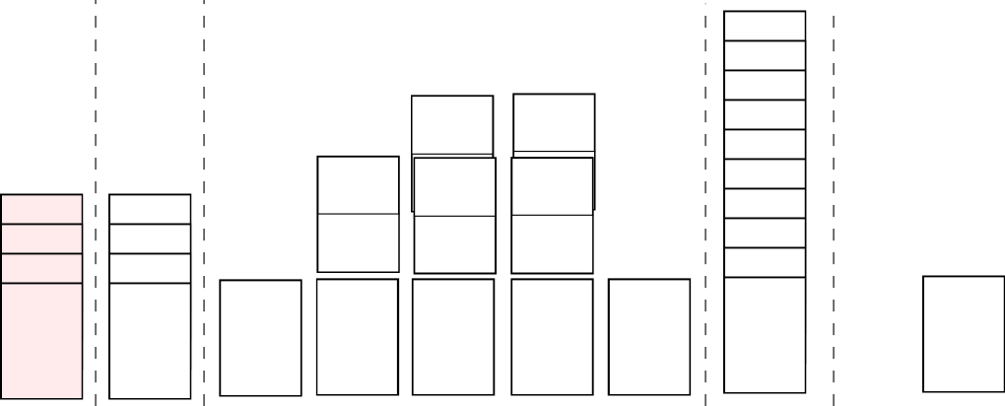

Requirements Stage

- Decide: First, you must choose whether to move on to the design phase. If you do, you must begin following the steps in the design stage instead of those described below. Otherwise:
- Draw: If you have less than five cards in your hand, you may draw cards until you have five.
- Work on Requirements: You take two cards from the documentation deck and place them to the far left side of the play area (red area above). You may forego drawing one or both of these cards to replace an existing unclear documentation card. In this case you may replace one card for each draw you gave up.

While the number of requirements cards that you need is up to you, a good maximum to keep in mind is six. There are problem cards that will target players with less than 1 requirement card, others that target those with less than 2, and so on. But once you have six requirement cards you need only worry about your requirements being unclear. Speaking of which, it will often be beneficial to replace unclear documentation, as these will make you vulnerable to certain problem cards.

- Play: You may put any number of programmer and concept cards from your hand into play (as long as you do not exceed your budget)
5) Discard: You may choose and discard any number of cards from your hand. You may also fire any number of your programmers or discard any of your concepts. Programmers that are fired leave their code behind and if other programmers wish to work on it they must pay a “help penalty” (see below under implementation).

The next time it is your turn, you will follow these steps once again, starting with the decision to move on or not. If you do move on, your new steps are below in the…

Design Stage 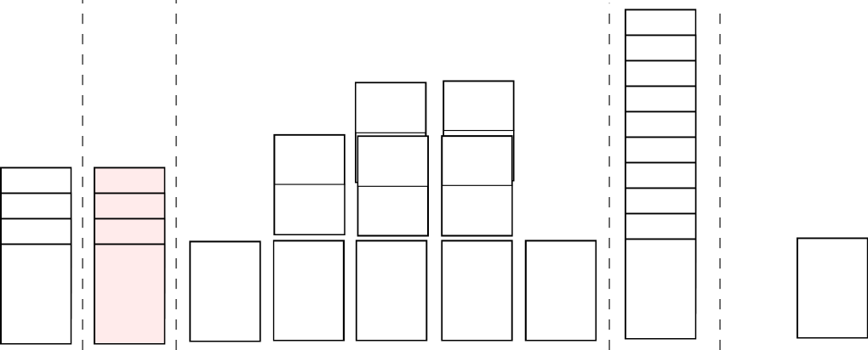

- Decide: First, you must choose whether to move on to the implementation phase. If you do, you must begin following the steps in the implementation stage instead of those described below. Otherwise:
- Draw: If you have less than five cards in your hand, you may draw cards until you have five.
- Work on Design: You may take two cards from the documentation deck and place them to the far left side of the play area (red area above). You may forego drawing one or both of these cards to replace an existing unclear documentation card. In this case you may replace one card for each draw you gave up.

Once again, six design cards should be enough to prevent almost all design-based problem cards. It is often beneficial to replace unclear documentation, as it can make you vulnerable to problems.

- Play: You may put any number of programmer and concept cards from your hand into play (as long as you do not exceed your budget)
5) Discard: You may choose and discard any number of cards from your hand. You may also fire any number of your programmers or discard any of your concepts.

Implementation Stage 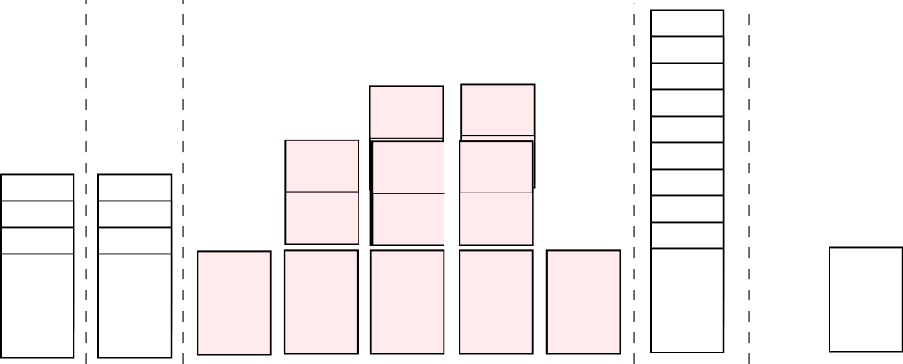

In this stage, you are vulnerable to problem cards, so be careful. Here you may find yourself paying the price if you made bad decisions earlier on. This also means that when your opponent enters this phase, make sure you are ready to cause them trouble with problem cards of your own.

- Problems: Each other player may play one problem card on you if you meet its criteria.
- Decide: If you have integrated code cards equal to or greater than the length of your project, you may choose to move on to the product delivery phase. Notice that these cards may or may not have bugs, and need not even have been inspected. But keep in mind that during the product delivery phase, these cards will be checked based on the quality requirement of your project, and if any bugs are found there will be consequences.
- Draw: If you have less than five cards in your hand, you may draw cards until you have five.
- Implement: Before you can even think about integrating code however, you must produce it. In this stage, each programmer that you control may take actions. A programmer’s skill determines how many skill points they have, and thus how many actions they may take. Programmers have 4 options on each turn, each consuming skill points. They may take any combination of actions as long as they have enough skill points. The four actions a programmer can take are:

  - Program Good Code (Cost = Complexity of your project)
Take one code card from the code deck and place it face-down above this programmer and above any code cards already above them. Because this is good code, place the blue side farthest from the programmer.
  - Program Rush Code (Cost = Half the project’s complexity, rounding up)
Same as above, but place the red side farthest from the programmer.
  - Inspect Code (Cost = 1 skill point)
Flip over one of this programmer’s face down cards of your choice. Be sure that the card’s red/blue facing relative to the programmer is maintained. If the card is a bug card this can potentially cause problems when the project is completed (remember your quality requirement?). Any nasty bugs that are found cause the code card directly above them to be discarded and the nasty bug to immediately be replaced with a code card of the same quality.
  - Fix a Bug (Cost = 1 skill point)
This programmer can fix a simple bug for one time point, replacing it with a card of the same quality from the code deck. A normal bug meanwhile is “fixed” by swapping it with the code card above it, or if it is the top code card it can be finally replaced. Thus it may be necessary to take several bug fixing actions to be rid of a normal bug. Bugs may be addressed and fixed in any order that you choose.

Fixing bugs can work wonders for meeting your quality requirement at the end of the game.

So, for example, a programmer with 4 skill and a project with a complexity of 2 could:
Program two good code (each costing 2 skill points)
Program one good code and inspect 2 code cards (2 + 1 + 1)
Inspect 2 code and fix two simple bugs (1 + 1 + 1 + 1)
Etc…

A programmer need not use all of his skill points in a turn.

Finally, instead of taking any normal action, a programmer may help. In this case the programmer may work on another programmer’s code as if it was his own, with a two point penalty, paid once for all actions taken. So a 4-skill programmer could take 2 points-worth of action on another programmer’s code column. These points may be combined with other programmers’ points to cooperatively create a code card, as long as enough points are available between them.
This is also the only way that code created by a programmer who no longer works for you can be effected. So be sure to hold onto your most productive programmers!

Or you may integrate 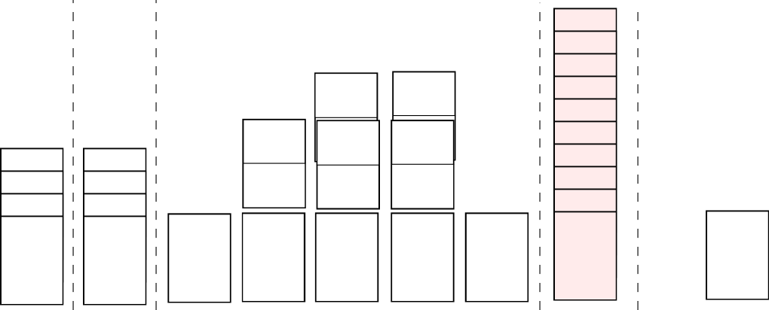

If you have completed code cards equal to the project’s length, you may integrate this turn instead of taking any programmer actions. In this case you take all of the code cards above one of your programmers and put them in a separate column to the right of all programmers. This represents your integrated code, which cannot be changed, nor effected by any player’s problems. Once you have integrated code equal to the length of your project you may move on to your product delivery!

Note: Be careful! Do not change the alignment of any of the cards when moving them, whether they are good or rushed code is still important.

- Play: You may put any number of programmer and concept cards from your hand into play (as long as you do not exceed your budget)
6) Discard: You may choose and discard any number of cards from your hand. You may also fire any number of your programmers or discard any of your concepts.

Product Delivery Stage 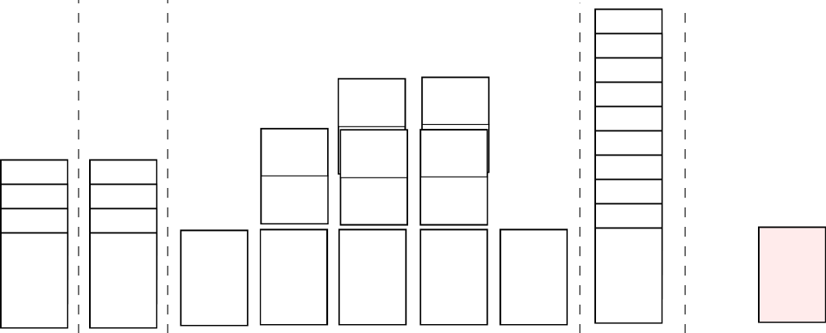
This is the final challenge for your project; will it meet with your client’s approval?

- Product Use: Take all of your code cards and turn them face-down (again keeping them aligned in the same way). You must now mix up their order (careful of the facing!) and one opposing player may choose to cut the pile once. Finally, reveal cards off of the top of the pile equal to your quality requirement. If they none are bugs, you win!

If any of the card revealed are bugs marked nasty bugs, you lose the game. These are bugs so severe that the product is completely unworkable, the customer is appalled and so is your boss. In this case the project is cancelled and beyond repair.

But if there are any simple or normal bugs, the project is flawed but can be fixed. In this case, you must place all of your code cards over a single one of your programmers. You may choose the programmer, but your opponent chooses the order that the code cards are arranged in. You must go back to the implementation stage and proceed as normal, attempting to once again finish your project. Keep in mind that you will once again be vulnerable to problems as you work out the bugs in your project, and your opponent would likely like nothing more than to seize victory from your grasp!

A Brief Glossary
- Discard – Place in the discard pile of the deck from whence the discarded card came.
- Help – When one programmer gives his time points to another, with a standard two-point penalty.
- Good Code – Code that is blue side-up if facedown, or blue-side-up if face-up.
- Phase – One of five parts of a single turn.
- Rush Code – Code that is red side-up if facedown, or red-side up if face-up.
- Stage – One of the five parts of the waterfall model, and therefor the game.

This document and all others packaged with it are Copyright© Alex Baker 2002. This document and all the Problems and Programmers files packaged with this document may be distributed freely, provided they remain unchanged and packaged together. Included files are: code1.bmp, code2.bmp, code3.bmp, code4.bmp, code5.bmp, code6.bmp, code-bck.bmp, concept.bmp, concept2.bmp, document.bmp, p-des.bmp, p-des2.bmp, p-misc.bmp, p-pers.bmp, p-pers2.bmp, p-req.bmp, p-req2.bmp, prog.bmp, prog2.bmp, prog3.bmp, prog4.bmp, project.bmp, instructions.doc and print_instructions.doc.

See appendix B for comments on this.

